Krugman Module 25 – Fractional Reserve Banking System
1 people will panic and everyone will take out their money
2 there would be regulation to make sure that investors would be liable for losses
3 100 x 1/0.1 = 1000
4 1000 – 1000 + 450 + 450 + 202.50 + 202.5 +…
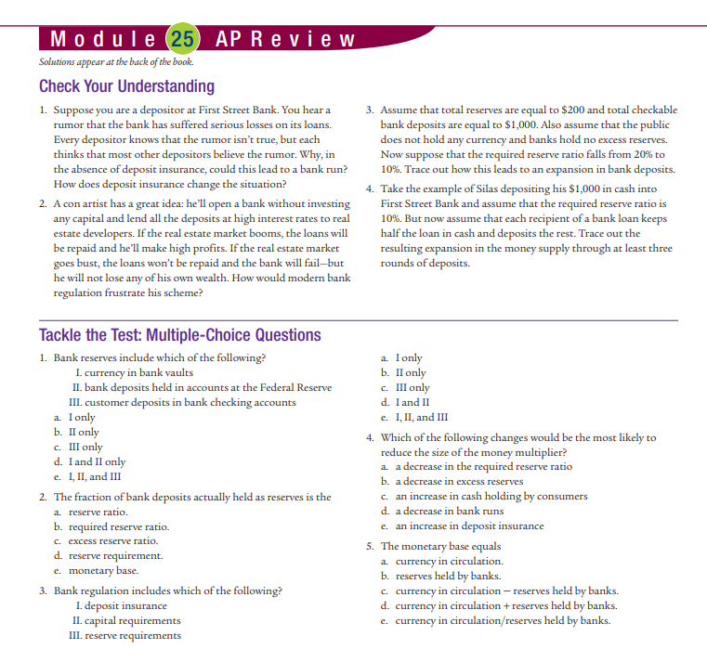
1 a decrease, b decrease, c decrease
2 a 5000 excess reserves.
b must hold additional 50 required reserves bank can lend 950
c 2000 x 1/0.05 = 40,000
MC
1d 2a 3e 4c 5d
